**Task 3 – Class Diagram and Design Pattern selection**

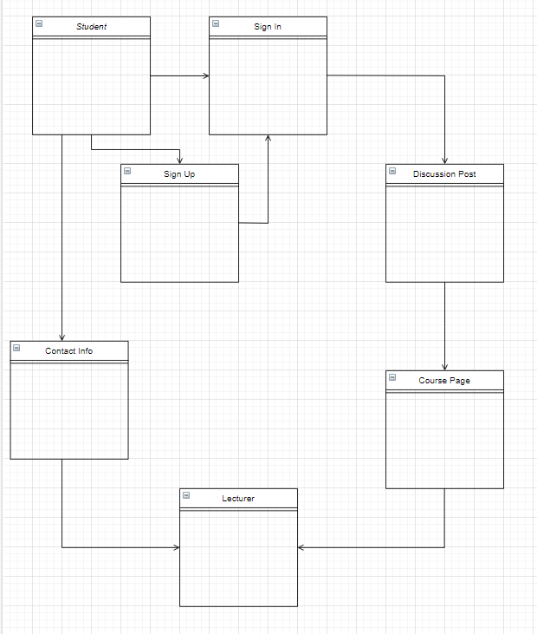

In this design, student must login in their account to post their question on the course page. However they only can go through the course page by picking certain course and look for their question.

For every questions which will be checked by our personal lecturer and they will put some tips on the questions to let other user can answer the questions and having with some idea on it. For some user who subscribe our software can contact our lecturer through Contact page and they can get some idea or answer from our lecturer they are also free to contact our lecturer anytime.